APPLICATION DEVELOPMENT AND EMERGING TECHNOLOGIES COMPREHENSIVE INTERVIEW GUIDE

Prepared For:
Johneros Puyo

Prepared By:
Jenefer Z. Ignacio

Course and Section:
BSCS – 3A

Date of Submission:
September 12, 2026

Introduction & Interviewer Instructions
This comprehensive interview guide, prepared by TechVision Consulting Inc., aims to assess the current state, technological readiness, and capacity of Manila Manufacturing Corporation (MMC). As a medium-sized company, it is important to identify MMC's specific operational needs as it seeks to adopt emerging technologies to modernize operations, improve efficiency, and remain competitive in the market.

I. Purpose of the Interview
This interview aims to evaluate MMC’s current operations, challenges, technology awareness, skills, budget, and readiness. TechVision Consulting Inc. will use the information gathered to develop a technology adoption recommendation report for MMC.

II. Interviewer Instructions
1. Introduce yourself as a Technology Analyst from TechVision Consulting Inc. and explain the purpose of the interview.
2. Inform the interviewee that the questions focus on MMC's manufacturing operations and potential adoption of emerging technologies.
3. Allow the interviewee to explain their answers thoroughly before asking follow-up questions.
4. Record important responses, operational pain points, and specific examples provided by the interviewee in the space provided.
5. Use probing questions such as "Why?" "How?", and "Can you elaborate?" when you need clarification.
6. Avoid leading the interviewee toward a particular technology.
7. Thank the interviewee for participating and outline the next steps.

Interviewee Information
Full Name: ___________________________________________________________________
Job Title / Position: ____________________________________________________________
Department / Unit: _____________________________________________________________
Years of Service at MMC: _______________________________________________________
Email / Contact Details: _________________________________________________________
Date & Time of Interview: _______________________________________________________

1. Background and Current State
Question 1: What are MMC’s main operational goals this year, and what major problems is the company facing right now?
Follow-up: How are these problems affecting MMC’s overall growth and daily business?
Response / Notes: ____________________________________________________________________________________________________________________________________________________________________________________________________________________________________

Question 2: Can you walk me through MMC's main manufacturing process, and where on the factory floor do delays usually happen?
Follow-up: How do these delays impact your delivery times to customers?
Response / Notes: ____________________________________________________________________________________________________________________________________________________________________________________________________________________________________

Question 3: What basic machines, software, or digital tools is MMC currently using to automate work on the factory floor?
Follow-up: As factory tools have evolved, how well do your physical machines connect with your computers today?
Response / Notes: ____________________________________________________________________________________________________________________________________________________________________________________________________________________________________

2. Technology Awareness and Readiness
Question 4: How familiar is MMC’s leadership team with emerging technologies like AI, Cloud, and IoT, and how do they stay updated on new tools?
Follow-up: How does management determine whether a new technology would be practical and beneficial for MMC’s operations?
Response / Notes: ____________________________________________________________________________________________________________________________________________________________________________________________________________________________________
Question 5: How would you describe MMC’s current use of technology in its day-to-day manufacturing and business operations?
Follow-up: Which processes currently rely most on technology and which processes do you think need improvement or modernization? Why?
Response / Notes: ____________________________________________________________________________________________________________________________________________________________________________________________________________________________________

Question 6: What are the main business goals or pressures pushing MMC to consider modernizing its tech operations right now?
Follow-up: What specific results would make you consider a new technology rollout a success?
Response / Notes: ____________________________________________________________________________________________________________________________________________________________________________________________________________________________________

3. Industry and Competitive Analysis
Question 7: Do you feel MMC is falling behind competitors in the local manufacturing industry because of technology gaps?
Follow-up:
If yes, what specific tools or automated systems do your competitors use that MMC is currently missing?
If no, what technological strengths or operational advantages give MMC an edge over its competitors?
Response / Notes: ____________________________________________________________________________________________________________________________________________________________________________________________________________________________________

Question 8: How quickly can MMC change its production speed or order volumes when customer demand or market trends change unexpectedly?
Follow-up: What limitations in your current factory setup stop you from making faster decisions when market demands shift?
Response / Notes: ____________________________________________________________________________________________________________________________________________________________________________________________________________________________________

Question 9: What industry regulations, safety rules, or quality standards are currently the hardest for MMC to follow and keep track of?
Follow-up: How could automated data collection or digital tracking help you meet these quality and compliance rules more easily?
Response / Notes: ____________________________________________________________________________________________________________________________________________________________________________________________________________________________________

4. Specific Technology Areas

I. Artificial Intelligence (AI)
Question 10: How does MMC currently view the use of Artificial Intelligence in its manufacturing and business operations?
Follow-up: Where do you think AI could help managers or employees solve day-to-day operational problems?
Response / Notes: ____________________________________________________________________________________________________________________________________________________________________________________________________________________________________

Question 11: What main concerns does MMC have regarding the setup cost, accuracy, or reliability of AI systems?
Follow-up: What factory tasks are your supervisors most hesitant to hand over to automated AI software?
Response / Notes: ____________________________________________________________________________________________________________________________________________________________________________________________________________________________________

II. Machine Learning
Question 12: How does MMC currently monitor equipment performance and handle unexpected machine breakdowns?
Follow-up: Do you think analyzing past equipment data could help predict potential machine failures? Why or why not?
Response / Notes: ____________________________________________________________________________________________________________________________________________________________________________________________________________________________________

Question 13: Does MMC use historical sales and production data to train models that forecast future product demand?
Follow-up: How do you currently estimate how many items to manufacture each month?
Response / Notes: ____________________________________________________________________________________________________________________________________________________________________________________________________________________________________

III. Augmented Reality (AR)
Question 14: How does MMC currently help warehouse workers pick parts and locate inventory across the facility?
Follow-up: How could showing digital instructions on top of physical items make warehouse work easier or faster?
Response / Notes: ____________________________________________________________________________________________________________________________________________________________________________________________________________________________________

Question 15: How do you currently give repair instructions to technicians, and do you think using AR on mobile devices could make machine maintenance easier?
Follow-up: How do technicians currently access or refer to manuals and repair instructions while working on factory equipment?
Response / Notes: ____________________________________________________________________________________________________________________________________________________________________________________________________________________________________

IV. Internet of Things (IoT)
Question 16: Are your factory machines or storage areas equipped with connected sensors that collect and share real-time data?
Follow-up: If not, how do you currently track machine temperatures, operational speeds, or storage conditions?
Response / Notes: ____________________________________________________________________________________________________________________________________________________________________________________________________________________________________

Question 17: How could getting instant data alerts from machine sensors help supervisors fix production line issues faster?
Follow-up: How quickly is management notified when a machine stops working or runs slowly?
Response / Notes: ____________________________________________________________________________________________________________________________________________________________________________________________________________________________________

V. Cloud Computing
Question 18: Does MMC store its business and operational files on local servers, or does the company use cloud services?
Follow-up: How easy is it for managers to securely check production reports when working outside the office?
Response / Notes: ____________________________________________________________________________________________________________________________________________________________________________________________________________________________________

Question 19: What concerns does MMC have about moving its factory data to the cloud, such as Internet connection stability or data safety?
Follow-up: Has MMC ever lost work hours due to local server crashes or lost computer files?
Response / Notes: ____________________________________________________________________________________________________________________________________________________________________________________________________________________________________

VI. Big Data Analytics
Question 20: How does MMC collect and organize large sets of data coming from sales, inventory, and factory lines?
Follow-up: What tools or methods do you currently use to identify trends and patterns in this information?
Response / Notes: ____________________________________________________________________________________________________________________________________________________________________________________________________________________________________
Question 21: How could having real-time access to factory data help managers make quicker daily production decisions?
Follow-up: What stops MMC from getting fast, clear answers from its operational data right now?
Response / Notes: ____________________________________________________________________________________________________________________________________________________________________________________________________________________________________

VII. Quantum Computing
Question 22: How familiar is MMC’s management team with Quantum Computing and its potential applications in areas such as supply chain planning?
Follow-up: How does management view technologies that may have long-term potential compared with technologies that can address MMC’s current needs?
Response / Notes: ____________________________________________________________________________________________________________________________________________________________________________________________________________________________________

Question 23: What complex scheduling, production, or supply chain problems does MMC currently face?
Follow-up: What is the most complicated planning or calculation problem your team handles today, and what makes it difficult to solve?
Response / Notes: ____________________________________________________________________________________________________________________________________________________________________________________________________________________________________

5. Skills and Capacity
Question 24: Do your factory workers and office staff have the technical skills needed to use and manage modern technology tools?
Follow-up: What specific skills are missing most among machine operators and supervisors?
Response / Notes: ____________________________________________________________________________________________________________________________________________________________________________________________________________________________________

Question 25: What training programs or learning steps does MMC offer when introducing new equipment or software to employees?
Follow-up: How does management address employee fears or concerns about automation replacing jobs?
Response / Notes: ____________________________________________________________________________________________________________________________________________________________________________________________________________________________________

6. Budget and Implementation
Question 26: Has MMC set aside a specific budget for acquiring new tech tools and upgrading factory operations this year?
Follow-up: If you are comfortable sharing, approximately how much of MMC’s budget is allocated to technology upgrades?
Response / Notes: ____________________________________________________________________________________________________________________________________________________________________________________________________________________________________

Question 27: What is MMC’s planned timeline for putting new technology tools onto the factory floor?
☐ 0-6 months
☐ 6-18 months
☐ 18+ months
Follow-up: Why is this timeline realistic based on your current production workload?
Response / Notes: ____________________________________________________________________________________________________________________________________________________________________________________________________________________________________

Question 28: What do you think is the biggest obstacle or risk to successfully adopting new technology at MMC?
Follow-up: How does management plan to address this obstacle during implementation?
Response / Notes: ____________________________________________________________________________________________________________________________________________________________________________________________________________________________________

Closing

Final Question
Is there anything else you would like to share about MMC’s technology needs, challenges, or plans for the future?

Final Statement
Thank you for your time, cooperation, and valuable insights. TechVision Consulting Inc. will analyze the information gathered from this interview to assess MMC’s current technology readiness and identify suitable emerging technology opportunities. The findings will contribute to a technology adoption recommendation report designed to address MMC’s operational challenges, improve efficiency, and support its digital transformation.

Additional Comments/Notes:
____________________________________________________________________________________________________________________________________________________________________________________________________________________________________

Interview Completion:
Interviewer’s Name: ____________________________________________________________
Date Completed: ______________________________________________________________
Interview Duration: _____________________________________________________________

AI Checker:
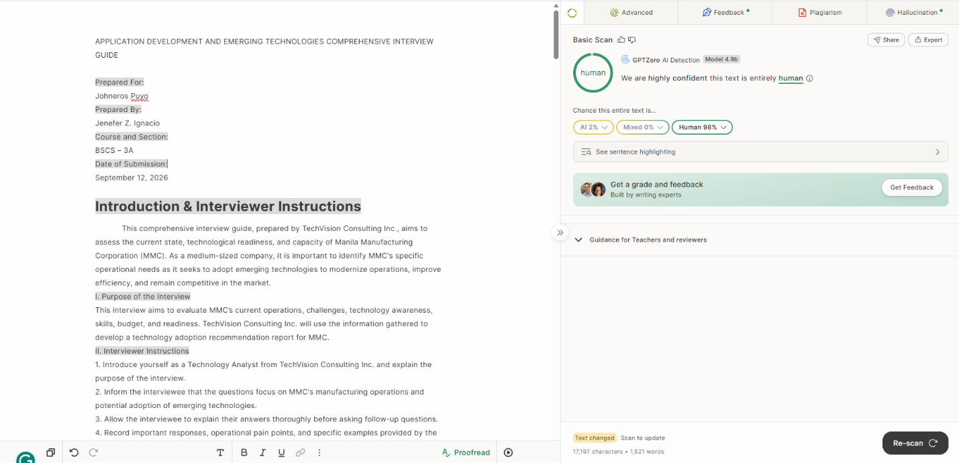

Grammarly:
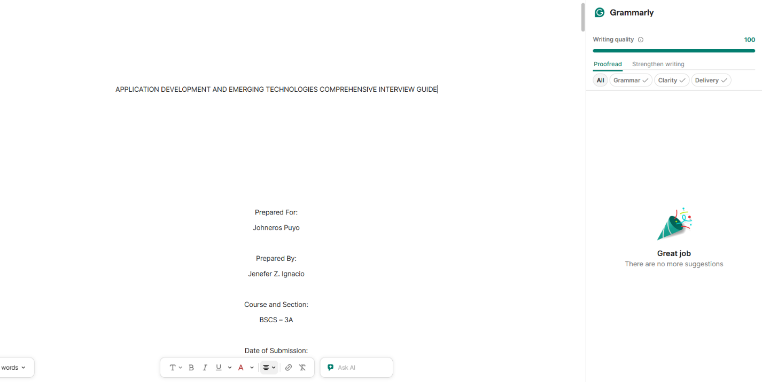

Rubric for Evaluation:
Criteria | Excellent | Good | Satisfactory | Needs  Improvement | Score
Completeness  of Sections | All 9 sections  complete and  well-organized | 7-8 sections  complete | 5-6 sections  complete | Less than 5  sections | /15
Question  Quality | Questions are  clear, relevant,  and probing | Most questions  clear and  relevant | Some questions  unclear or  irrelevant | Many questions  unclear or  irrelevant | /15
Coverage of  Technologies | ALL emerging  technologies  covered  thoroughly | Most  technologies  covered | Some  technologies  covered | Few  technologies  covered | /25
Alignment with  Scenario | Questions  perfectly match  the MMC  scenario | Questions  mostly match  the scenario | Some questions  match the  scenario | Questions do not  match the  scenario | /10
Open-Ended  Questions | Excellent mix with  effective probes | Good mix with  some probes | Some open-  Ended questions | Few open-ended  questions | /10
Professional  Format | Very professional,  clean, and  organized | Professional  with minor  issues | Somewhat  professional | Disorganized or  messy | /15
Practicality | Questions are  practical and  usable | Most questions  are practical | Some questions  are practical | Questions are  impractical | /10
Total Score: ____ / 100

